Write a C program to simulate a Deterministic Finite Automata (DFA) for the given language representing strings that start with a and end wit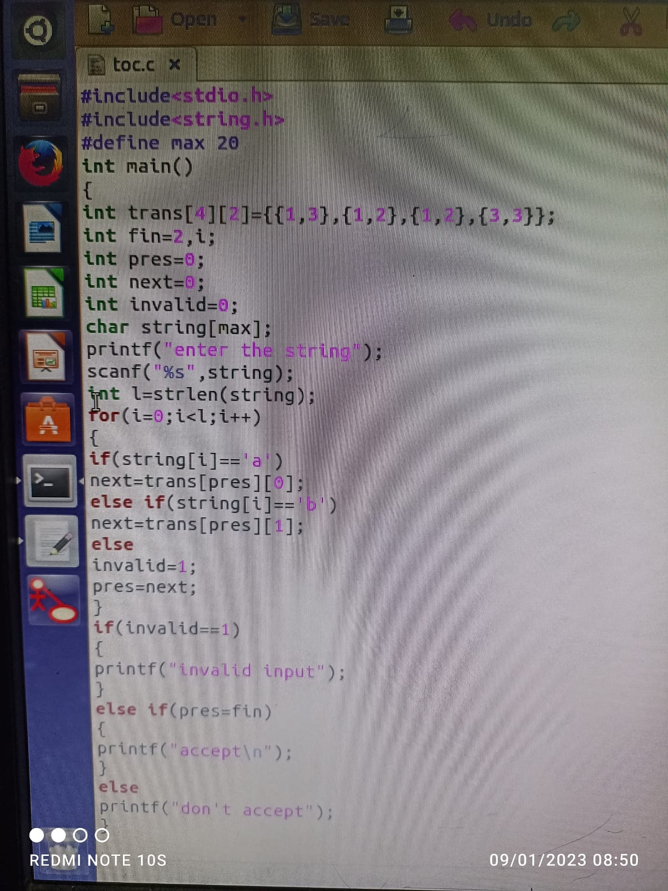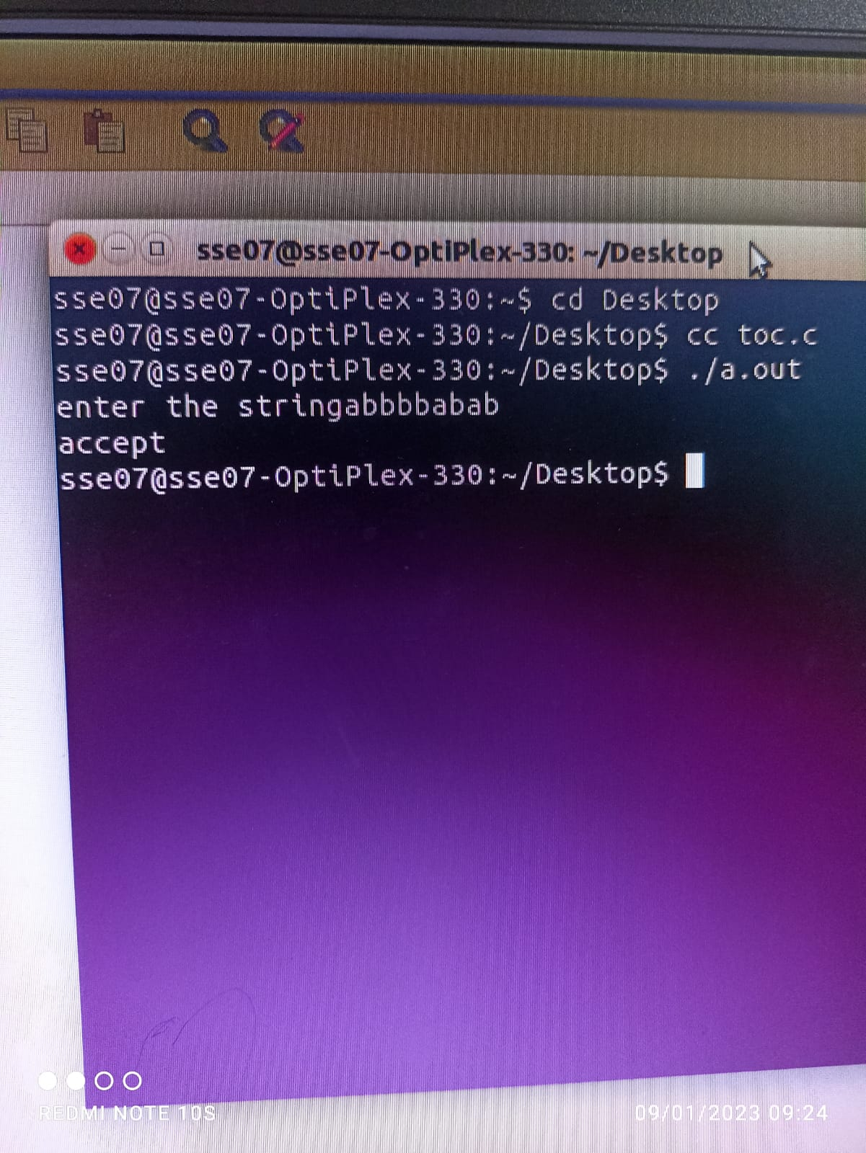

Write a C program to check whether a given string belongs to the language defined by a Context Free Grammar (CFG) S → 0A1 A → 0A | 1A | ε

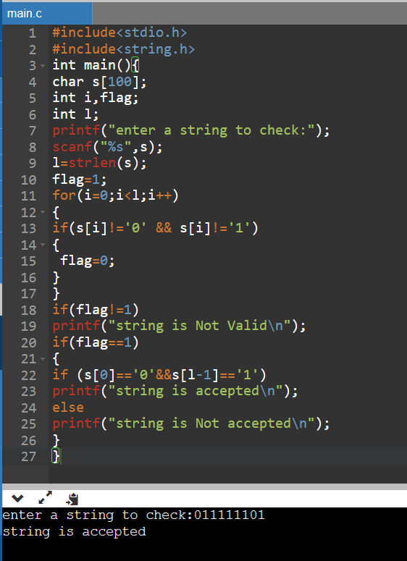

Write a C program to check whether a given string belongs to the language defined by a Context Free Grammar (CFG) S → 0S0 | 1S1 | 0 | 1 | ε

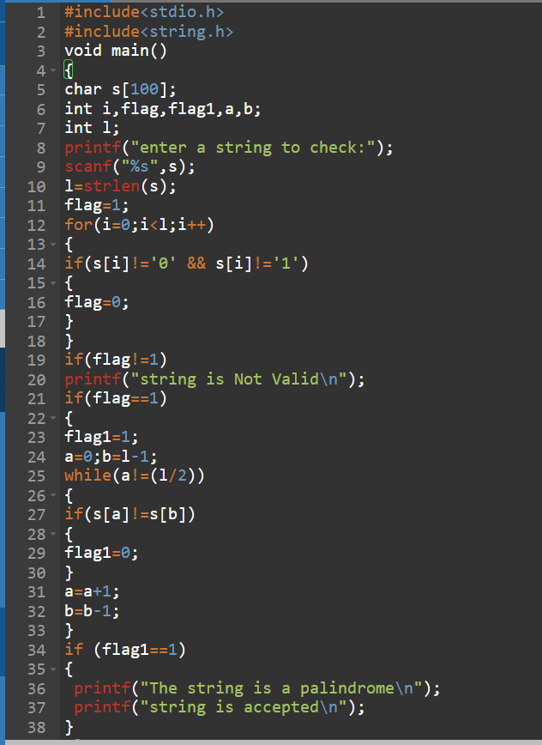

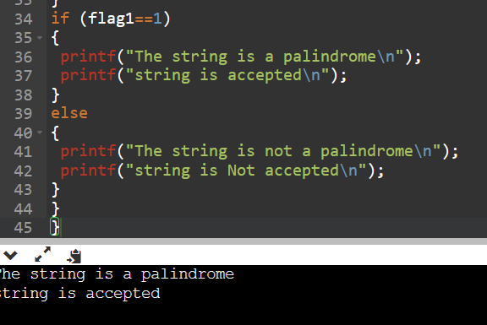

Write a C program to check whether a given string belongs to the language defined by a Context Free Grammar (CFG) S → 0S0 | A A → 1A | ε

Write a C program to check whether a given string belongs to the language defined by a Context Free Grammar (CFG) S → 0S1 | ε